Case study

Read the case study and the scenario below to be able to carry on with your practical task.

The Jaws of Life rescue system

Every year there are hundreds of accidents on our roads. Many people lose their lives, and others are seriously injured. Sometimes people who are trapped in the wreckage can die if they are not rescued in time. Advances in technology have helped to reduce the number of these deaths. Emergency workers use special tools to cut and open the crushed metal parts of the vehicle, so that doctors and paramedics can get to the accident victims and give them medical treatment. These tools are called the Jaws of Life.

Scenario

The rescue services in your area need a set of Jaws of Life. They have asked you to make a model of the Jaws of Life. The model must:

* Be made with cardboard.
* Use split pins to join the cardboard pieces.
* Have a hydraulic system using syringes and plastic tubing.
* Be strong and sturdy.
* Be between 200mm to 300mm in length, and between 200mm to 500mm in height.

You will work through different stages of the Design Process (IDMEC)

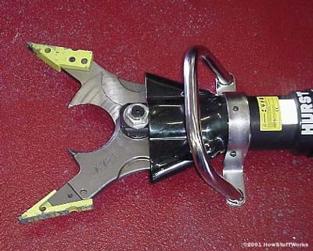 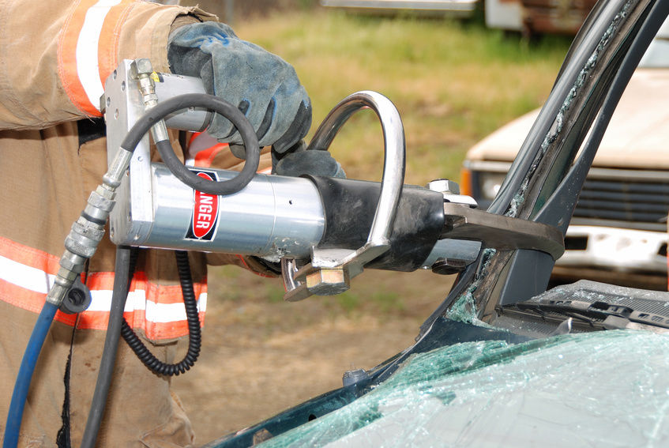

Activity 1 (20 marks)

Find information about the Jaws Of Life, and then answer the questions that follow.

1. What is the Jaws of Life tool used for?

__________________________________________________________________________________________________________________________________________________________________________________________________________________

(2)

1. Who uses the Jaws of Life tool?

____________________________________________________________________________________________________________________________________________

(1)

1. When was the tool invented?

______________________________________________________________________

(2)

1. Who invented the tool?

______________________________________________________________________

(2)

1. Write the three types of Jaws of Life tools that we have.

_____________________________

_____________________________

_____________________________

(3)

6. The Jaws of Life tool uses hydraulics to do its job. Explain the difference between a hydraulic system and a pneumatic system.

____________________________________________________________________________________________________________________________________________

(2)

7. Why does a hydraulic system provide a stronger push than a

pneumatic system?

__________________________________________________________________________________________________________________________________________________________________________________________________________________

(2)

8. Give 4 examples of items that use a hydraulic system.

_____________________________

_____________________________

_____________________________

_____________________________

(4)

9. Look at the diagram of a hydraulic system below. What must we do if we want to get a stronger output movement?

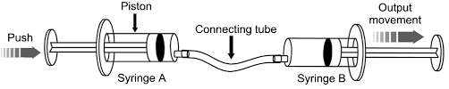

____________________________________________________________________________________________________________________________________________

(2)

Activity 2 (10 marks)

Read the problem statement/scenario and write a design brief, specifications and the constraints

1. Write a design brief (A short statement that describes the problem).

____________________________________________________________________________________________________________________________________________________________________________________________________________________________________________________________________________ (2)

1. Write 5 specifications.

________________________________________________________________________________________________________________________________________________________________________________________________________________________________________________________________________________________________________________________________________________________________________________________________________________________________________________________________________________________________________________________________________________________ (5)

1. List 3 constraints you might encounter (Explain how it is a constraint)

________________________________________________________________________________________________________________________________________________________________________________________________________________________________________________________________________________________________________________________________________________________________________________________________________________________________________________________________________________________________________________________________________________________ (3)

Activity 3 (10 marks)

1. Sketch two free hand drawings showing two different Jaws Of Life designs you are likely to build.

|  |  |  |  |  |  |
| --- | --- | --- | --- | --- | --- |
| Design 1 | | | Design 2 | | |
|  | | |  | | |
| Design 1 | | Design 2 | | |
| Criteria | Mark | Criteria | | Mark |
| Drawing | /2 | Drawing | | /2 |
| Labeling | /1 | Labeling | | /1 |
| Dimensions | /1 | Dimensions | | /1 |
| Total: / 8 | | | | |

1. Which design do you choose to build as your final product? State a reason for your choice. ______________________________________________________________________________________________________________________________________________________________________________________________ (2)

Activity 4 (10 marks)

Write step by step instructions of how you will go about making the Jaws of Life tool. Explain what you will do at every stage of the design process.

|  |
| --- |
| Investigate  ___________________________________________________  ___________________________________________________  ___________________________________________________  ___________________________________________________  _________________________________________________(2) |

|  |
| --- |
| Design  ___________________________________________________  ___________________________________________________  ___________________________________________________  ___________________________________________________  _________________________________________________(2) |

|  |
| --- |
| Make  ___________________________________________________  ___________________________________________________  ___________________________________________________  ___________________________________________________  _________________________________________________(2) |

|  |
| --- |
| Evaluate  ___________________________________________________  ___________________________________________________  ___________________________________________________  ___________________________________________________  _________________________________________________(2) |

|  |
| --- |
| Communicate  ___________________________________________________  ___________________________________________________  ___________________________________________________  ___________________________________________________  _________________________________________________(2) |

Activity 5 (20 marks)

You are required to make a poster about the Jaws of Life. Your poster must:

* Have a suitable heading.
* Have a detailed drawing of the Jaws of life you have designed (must be labeled and show dimensions).
* Have a written explanation of what the Jaws of Life is, who uses it, what it is used for and who invented the tool.
* Provide information about stage 2 of the design process. That is, the design brief, specifications and constraints.
* Be decorated and neat
* Be made on an A3 page.

The marking rubric on the next page will be used to mark your poster. Use it as a guide when making your poster.

Marking rubric

|  |  |  |  |  |
| --- | --- | --- | --- | --- |
| Criteria | Level/mark | | | |
| Poor  [0 - 1 mark] | Satisfactory  [2 - 3 marks] | Good  [4 marks] | Excellent  [5 marks] |
| 1. Aesthetics - How the poster looks | No sign of decoration. The poster is not pleasant to look at | Poster looks okay, some effort was put into making sure it looks nice. | Poster looks good. Learner put in effort to make sure it looks good. Evident use of decoration and colour. | Poster is excellent. Time and effort was put in to make sure that the poster is immaculate. Poster is colourful and neat. |
| 1. Jaws of Life explanation | No explanation of what the Jaws of Life is. | Learner wrote a brief explanation of what the Jaws of Life is, most of the information is omitted. | Learner gave a good explanation of the Jaws of Life tool. However, some information might not be present. | Learner gave an excellent explanation of the Jaws of Life tool, he/she has answered all the questions one might have about the tool. |
| 1. Information about stage 2 of design process | Learner provided no information about design stage number 2 | Learner only provided little information about stage 2 of design process. Most of the information is missing or incorrect. | A good amount of information of stage 2 was provided. Some information might be missing or incorrect. | Learner provided all the information that is needed. The information is correct. |
| 1. Drawing of Jaws of Life | No drawing provided | Drawing provided but is not neat/correct. | Learner made a good drawing. Most of the details have been provided. | Excellent drawing provided showing all the details (labeling and dimensions) |
| Total: _______ / 20 | | | | |